ASEM 2024 International Annual Conference Paper Formatting Guidelines

Abstract #XXX
[Do not include author information for peer review submission]
____________________________________________________________________________________________

Abstract
This document presents instructions for preparing a manuscript for the American Society for Engineering Management International Annual Conference Proceedings. Please note that your submission will not appear in the proceedings unless it conforms exactly to the required format. Please proofread your submissions carefully for typographical, spelling, or grammatical errors. We strongly encourage you to use this document as a template for developing your manuscript.

Keywords
Provide a few keywords, separated by commas.

Introduction
This template will contain information on preparing the manuscript for the American Society for Engineering Management International Annual Conference Proceedings. The remainder of this template will provide details on general formatting style, exhibit formatting, author listing, paper structure, reference style, author biography (for final paper only), and appendix.
Two versions of the template will be provided, one for peer-review paper preparation and one for final paper preparation. This version is for the final paper submission, where instructions on author listing will be provided.

Manuscript Format
The paper size is 8.5 x 11 inches, this is different than the A4 paper size. Margins are 1 inch for top, bottom, left, and right margins. The acceptable paper length, including all exhibits and references, is between 4 to 10 pages. Appendices are not included in the 10-page limit, however, only include relevant appendices. Final papers that do not meet this requirement will be rejected. We recommend that you use this template directly.

Type, Font, and Text Body
The manuscript should be prepared in 10-pt Times Roman, single-spaced, with 1-inch margins all around. Use blank lines only above headings. Avoid unnecessary capitalization. Do not use quotation marks except for quotes. Left justify headings and sub-headings. All continuing text should be fully justified.
Do not indent the paragraph immediately after a heading or subheading. Second paragraph onward, use 0.25” indentation. Do not leave any blank lines between paragraphs.

Language
English is the official language of the IAC Proceedings.

Footnotes
Footnotes should not be used.

Page Numbers
Page numbers are already included in the footer. Do not make any changes to the page numbers.

Header and Footer
Headers will be different for the first page, do not change the header on the first page. Authors' last names should be added to the header on the second page onwards when submitting the final paper. Do not make any changes to the footers.

Headings and Sub-headings
Please limit the headings and sub-headings level to three levels. Section and subsection headings should be left justified and bold. Leave a single blank line before each heading and sub-heading. Do not number the headings and subheadings.

Major Section (Level 1) Headings. Major section headings (first level) are to occupy a single line alone, in bold, 12 pt font and should have the First Letter of Every Main Word Capitalized as in This Phrase. Examples of first-level heading in this template are “Introduction”, and “Manuscript Format”. Do not number the headings and sub-headings.

Second Level Sub-heading. The second level sub-headings should be bold, 10 pt, and occupy a single line alone. Examples of second-level sub-headings in this template are “Headings and Sub-headings”, and “Header and Footer”.

Third Level Sub-heading. An example of a third-level sub-heading is the heading for this paragraph. The third level sub-headings should begin on the first line of the paragraph. Capitalized main words and bolded, and a period should follow the heading phrase.

Specific Section Instructions
This section describes specific instructions for page layouts, exhibits, and special sections.

Paper Title and Author Information
The first page shall contain the title in full capital letters, centered across the entire page. Use 14-pt, bold. Times New Roman font for the paper title. Leave one single blank line (14-pt) between the page border and the first line of the title, and one single blank line (14-pt) between the last line of the title and the abstract number.
Include your abstract number by updating the XXX. At this double-blind review stage, do not include any author information. After the abstract number, the next line should contain a single drawn thin line.

Paper Structure
The paper should include at least the following sections: abstract, introduction, text body, conclusions, and references. Acknowledgment of funding support and/or any other kind of assistance should be contained in an Acknowledgements section located immediately before the References.

Abstract. All manuscripts are to include an abstract of no more than 250 words. The abstract should give purpose, scope, and principal results and conclusions. It should not contain literature citations or formulas.

Introduction. The introduction should state the problem or issue addressed in the paper, the background surrounding the elements of the paper, and the reason for the study.

Text Body. Please use appropriate headings and sub-headings within the text body to organize your manuscript. Some recommended headings include Literature Review, Methodology, Data Collection, Analysis, Results, Discussions, and Implications to Engineering Management.

Exhibits (Label for all Tables, Figures) and Captions. All Figures and Tables will be labeled as Exhibits. Number the Exhibits consecutively, and place them within the body of the text, in bold. A period should follow the exhibit number. The title of each exhibit should follow the heading and exhibit number and be followed by a period.
Do not box exhibits. Center the Exhibit number and title. Cite each Exhibit in the text before it appears. Use a portrait layout where possible. As an example, Exhibit 1 shows the typical paper sections and their definitions and Exhibit 2 shows a graph with a multiple-line title.

Exhibit 1. Typical Sections of Your Paper.
Sections | Definitions
Abstract | Purpose, scope, principle results, and conclusions
Introduction | Problem or issue, background, and reason for the study
Text Body | Methodology, analysis, or other value-added process
Conclusions | Summary of the result of this study in plain English
Recommendations | Specific steps to follow as a result of this study
Acknowledgments | (only in the final paper submission)
References | Published sources of information used in support of this study
Appendix | Supplementary materials that are not essential to the body of the paper
About the Author(s) | (only in the final paper submission)

A single blank line should separate the text from the exhibit title and separate the bottom of the exhibit from the subsequent text that follows. Excessive white space should be avoided. Some white space at the bottom of a page is acceptable if it precedes an exhibit or new section heading. The previous page is an example of where such white space appears to be logical, as the exhibit title must be above the exhibit.

Exhibit 2. Example of a Graph which is a Bar Chart Depicting Grade Distribution for a Course Mid-term Exam with a Title in Enough Detail that Requires a Multiple Line Title.
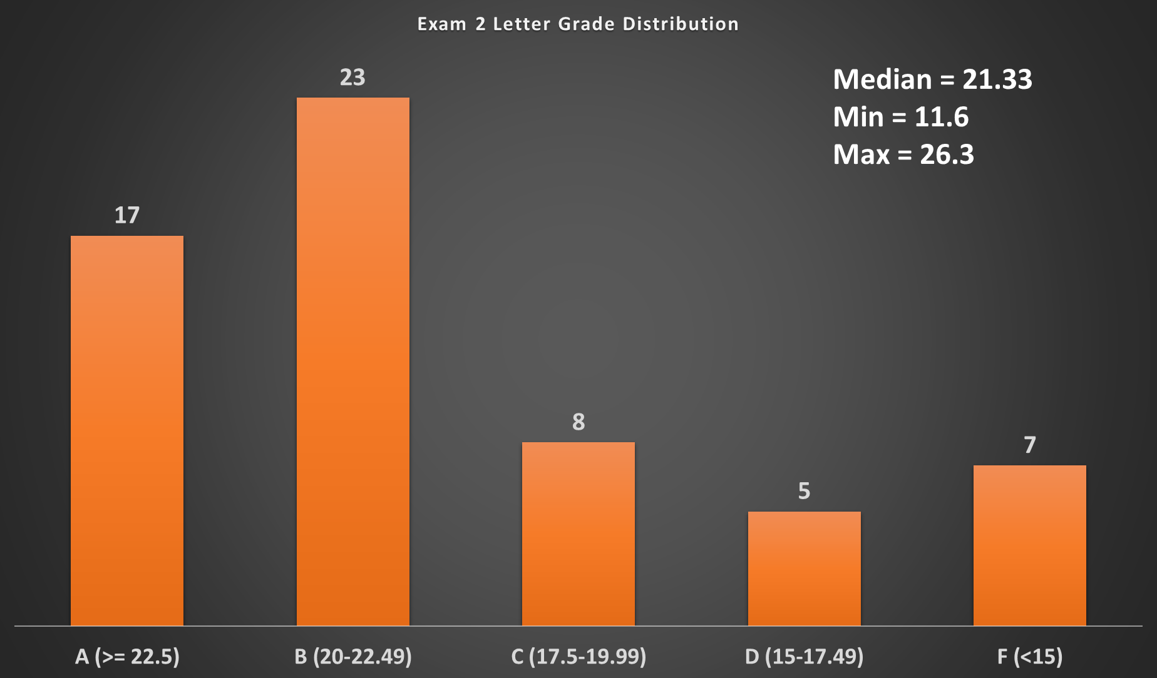

Mathematical notations and equations. Each displayed equation should be preceded and followed by a single blank line. Display only the most important equations, and number the equations referenced in the text. Within the display, enclose the equation number in parentheses and place it flush with the right-hand margin of the column. Equation (1) is shown below.
(1)

References. References should be complete, clear, styled as shown below and listed alphabetically by author (chronologically for a particular author). Place the list of references after recommendations. The section should begin with the major heading References. Only references cited in the text should be included.
Use the American Psychological Association (APA) Style of referencing for both in-text citations and reference lists. For more information on APA style, please see the Basics of APA Style tutorials on the APA website http://www.apastyle.org/learn/tutorials/basics-tutorial.aspx. Another good source of information can be found at Purdue Online Writing Lab at http://owl.english.purdue.edu/owl/section/2/10/.
Following APA Style, the in-text citation should be (Author, year) for any form of reference including journal articles, conference proceedings, books, and other forms of publications. Examples of in-text citations: (Denton, 1996) for one author, (Amos & Sarchet, 1980), and (Keating, Jacobs, Dryer, Unal, & Sousa-Poza, 2000) for two to seven authors. For proceedings or publications on CD-ROM, the in-text citation remains the same as in (Price-Wilkin, 2002).
For the list of references at the end of the manuscript, following the APA style, the reference should contain Author(s)’ Last and First Name, (Year). Title of manuscript (capitalize the first letter only). Publication Title (e.g. Journal Title, Conference Name) in Italics, Volume (Issue), pages. Please see the References section of this template for more information. Use hanging indentation to distinguish individual entries, the indentation should be one-half inch from the left margin. Do not insert blank lines between references.
In the Reference list of this template, the first reference is a website, the second reference is a book, the third reference is a refereed journal article, the fourth reference is a printed proceeding from a conference, the fifth reference is a conference proceeding on CD-ROM, and the last reference is a website.
If you are using a word processing software that has a citation and referencing capability, we recommend using it, however, care should be taken in checking the correctness and accuracy of such citations and references.

Recommendations
We strongly encourage you to use this document as a template for developing your manuscript.

Acknowledgment
If applicable, provide your acknowledgment here. (only in the final paper submission)

References
American Psychological Association. (2013). The Basics of APA Style. Retrieved from American Psychological Association: http://www.apastyle.org/learn/tutorials/basics-tutorial.aspx
Amos, J. M., & Sarchet, B. R. (1980). Management for Engineering. Englewood Cliffs: Prentice Hall.
Denton, K. D. (1996). Imprinting change on your organization. Industrial Management, 38(6), 4-7.
Keating, C. B., Jacobs, D. A., Dryer, D., Unal, R., & Sousa-Poza, A. (2000). Design of collaborative engineering work systems. Proceedings from the 2000 ASEM National Conference, (pp. 435-442). Virginia Beach.
Price-Wilkin, J. (2002). Using the world-wide-web to deliver complex electronic documents: Implications for libraries. Proceedings of the 2002 ASEE Annual Conference, (CD-ROM).
Purdue Online Writing Lab (OWL). (2013). APA Style. Retrieved from Purdue OWL: http://owl.english.purdue.edu/owl/section/2/10/

Appendices
Please number appendices continuously and refer to Appendices in the text. Only include an appendix if necessary.

